**Belt & Road Regatta (Beihai) 2024**

**NOTICE OF RACE**

**9thOctober -12thOctober 2024**

**Beihai, China**

The notation “[NP]” in a rule means that a boat may not protest another boat for breaking that rule. This changes RRS 60.1(a).

The notation “[SP]” means the standard penalties may be used by race committee (RC) without hearing. This changes RRS 63.1 and A5. According to the situation, the penalty shall be the score of the best race of the day plus 1.

1. **Rules**

**1.1** The regatta will be governed by the rules as defined in The Racing Rules Of Sailing (RRS).

**1.2** Add rule 41(e): help to recover from the water and return on board a crew member provided the return on board is at the approximate location of the recovery.

**1.3** RRS Appendix WP-Waypoint Rules will apply.

**1.4** No national authority prescriptions will apply.

**1.5** If there is a conflict between languages the English text will take precedence.

**1.6** When RRS 20 applies, a boat may use <VHF72> to indicate her call for the room to tack or her response.

**1.7** Teams should carry their own life jackets that comply with ISO12402-5 or higher standard, VHF portable radios and portable GPS.

**1.8** For long distance race the requirements of Offshore Special Rules (OSR) Cat 4 will apply. Where the details of the special rules cannot be met, OA may accept alternative rules. - strongly recommended that all boats use AIS.

**1.9** If there is a conflict between NoR and SIs, SIs will take precedence. This changes RRS 63.7.

1. **SAILING INSTRUCTIONS (SIs)**

The SIs will be available after registration.

1. **COMMUNICATIONS**

**3.1** Notices will be posted on the official notice board at the venue. The on-line auxiliary notice board will be at the WeChat " *Belt and Road International Regatta* Group".

**3.2** [DP] While racing, except in an emergency, a boat shall neither make voice or data transmissions nor receive voice or data communications that are not available to all boats.

1. **ELIGIBILITY AND ENTRY**

**4.1** Eligible Boats

The OA plans to supply 24 J80-class boats with third-party liability insurance and valid certificates issued by the authority of registration area. Teams may bring their own boats and sails of the same classes to the competition. Their own equipments shall meet the requirements of the class rules, and after passing the measurement check, they will participate in the competition with their own boat and sails.

**4.2** Eligibility

4.2.1 Boats may be entered by their member national authority, cities, clubs or the owner of the boat approved by OA.

4.2.2 At least one helmsman on board of each boat shall have competent racing skills and experience. Two competitors on board of each boat shall have experience for such type of competitions.

4.2.3 Have the personnel insurance prescribed as NoR 21.

**4.3** Entries

The entry time is from the publication of this notice of race to 17:00 on September 10th, 2024. Entry Form, together with the documents and materials as the following, shall be received by brr_info@163.com no later than that time limit (The title of the email may indicate the name of the team):

4.3.1 Entry form with confirmed name list and declaration of the relevant competition experience of the competitors as required by the NoR 4.2.2;

4.3.2 Team introduction, including text introduction within 400 words, photo and VCR of the crews/team.

4.3.3 Insurance (copies) prescribed as NoR 21 and for boats that not charted through the organizer, shall provide their boat’s certificate；

4.3.4 Paper Entry Form with signature of boat owner or the person in charge and the Disclaimer of Liability for crew shall be provided at On-Site Registration. The OA reserves the right to decline the entry due to the eligibility and number of the boats.

The entry form is available from the regatta contact. Entry Procedure will be completed when receiving the confirmation of OA.

**The entry method of paying the fee first and submitting the entry form later will be declined by the OA.**

**5 FEES**

**5.1** The following fees should be paid to enter the regatta:

Entry fee: 5000 RMB (Including accommodation in no more than 3 standard rooms from October 9th to 12th). For entries withdrawn before September 20th 2024, the entry fee will be deducted 3% as the handling fee. For entries withdrawn after September 20th 2024, no entry fee will be refunded.

Boat chartering fee: see NoR 15

Equipment deposit: see NoR 15

**5.2** Transfer the entry fee and boat chartering fee in advance to the bank accounting in **Appendix 5** after receiving the entry confirmation.

**5.3** The equipment damage deposit **must** be paid in cash at the on-site registration. Equipment Damage Deposit will be fully returned if equipment has no damage after the competition. When damage occurred, the team will compensate in according to the actual level.

Please send the entry information and the bank transfer receipt separately to the entry mailbox. Entry is considered valid after receiving confirmation from the OA.

**6 CREW LIMITATION**

The following table specifies the minimum and maximum number of the team member that shall be on board during racing

|  |  |  |
| --- | --- | --- |
| Class | Min number of persons | Max number of persons |
| J80 | 4 | 6 |

**7 [NP]ADVERTISING**

**7.1** World Sailing Advertising Code will be applied. The OA has the right to reject the team’s advertisements that conflict with government regulations and the regatta’s sponsors. For any doubts, please communicate with the OA as early as possible. All possible advertisements on the boat shall be briefly listed while entry. If there are any changes in advertisements, the OA should be informed.

**7.2** Teams may display their team’s name, image or advertising on each side of the hull and clean them up after the regatta. The location of such advertising is shown as Appendix 4 and the maximum size shall not be larger than the size for J80: 450mm high and 2000mm long.

**7.3** Boats should display the advertising of the regatta’s sponsors, such as the bow and backstay flags, according to NoR and SIs. Before leaving the port, before the start of the race, and after the finish of the race, the boats should display the regatta flag. Advertising materials such as sponsor logo, backstay flag and regatta flag will be supplied by the OA. If the team damages the advertising supplied by the OA deliberately, the OA has the right to protest.

**8 RACE DISCIPLINE**

The event will consist of course races and long distance races.

**9 SCHEDULE**

|  |  |
| --- | --- |
| Date/Time | Activity |
| D1 Wednesday, 9th October, 2024 | Registration, Boats Draw, Boat Distribution, Equipment Inspection，Practice |
| 1630 | Briefing |
| D2 Thursday, 10th October, 2024 | Racing Day  1030 First Warning Signal |
| D3 Friday, 11th  October, 2024 | Racing Day  1030 First Warning Signal |
| D4 Saturday, 12h  October, 2024 | Racing Day  1030 First Warning Signal  1800 Awards ceremony |
| D5 Sunday, 13h  October, 2024 | Departure |

**10 EQUIPMENT INSPECTION**

**10.1** The boats shall be available for equipment inspection on-site at any time by TC’s instruction.

**10.2** Teams may bring their own equipment including spinnaker comply with the requirements, but they should be measured before racing. Equipment inspection will begin at 9:00 on October 9.

**11 VENUE**

Appendix 1 shows the race area. It’s for reference only.No ground of redress shall be made on them.

**12 COURSE**

Appendix 2 shows the race course.

**13 PENALTY SYSTEMS**

**13.1** Rule 44.1 is changed so that the Two-Turns Penalty is replaced by the One-Turn Penalty.

**13.2** Decisions of protest committee will be final as provided in RRS 70.5（b）.

**13.3** Umpire may apply. See the SIs for details.

**14 SCORING**

**14.1** Nine course races(including LDR) will be scheduled. One race is required to be completed to constitute a series.

**14.2** A boat’s series score will be the total of her race scores for course races.

**14.3** LDR will be a one-off race and will be scored separately, No more prize for LDR.

**15 Boat Chartering**

**15.1** The following are the equipment rental prices (in RMB) and quantities.

|  |  |  |  |  |
| --- | --- | --- | --- | --- |
| Class | Price for race | Price for practice | Damage Deposit | Owner |
| J80(24) | free | 2000/day | 5000 | Guangxi Yachting Association |

**15.2** Free Chartering time is from October 9 to October 12, 2024. If you need the boats three days before 9th October for practicing, the charter fee for those days is as shown above. Please contact the owner.

**15.3** Equipment provided by the OA is distributed by draw. After the return of equipment is verified by the OA, the equipment deposit will be refunded. If any damage occurred, compensation shall be paid.

**15.4** No ground of redress shall be made on the quality of the chartered equipment.

**16 [DP] BERTHING**

Boats should be kept in their assigned places or other designated area.

**17 [DP] HAUL-OUT RESTRICTIONS**

Keelboats shall not be hauled out during the event except with and according to the terms of prior written permission of RC.

**18 [DP] Diving equipment and plastic pools**

Underwater breathing apparatus and plastic pools or their equivalent shall not be used around keelboats between the preparatory signal of the first race and the end of the event.

**19 DATA PROTECTION**

**19.1** For safety reasons, it is possible for the boat to carry the trackers provided by the OA. If the tracker malfunctions or ceases to operate, the location information must be reported in other ways in accordance with SIs.

**19.2** The OA has the right to place cameras on board for media purposes. For the boat who refuses to carry trackers and cameras supplied by the OA, the OA may decline her registrations, cancel her registration, or disqualify her.

**20 RISK STATEMENTS**

**20.1** RRS 3 states: ‘**The responsibility for a boat’s decision to participate in a race or to continue to race is hers alone**.’ By participating in this event each competitor agrees and acknowledges that sailing is a potentially dangerous activity with inherent risks. These risks include strong winds and rough seas, sudden changes in weather, failure of equipment, boat handling errors, poor seamanship by other boats, loss of balance on an unstable platform and fatigue resulting in increased risk of injury. **Inherent in the sport of sailing is the risk of permanent, catastrophic injury or death by drowning, trauma, hypothermia or other causes.**

**20.2** All Competitors shall sign a "Disclaimer" provided by the OA.

**20.3** By taking part in the event, each Competitor agrees and acknowledges that:

20.3.1. They are aware of the inherent element of risk involved in the sport and accept responsibility for the exposure of themselves and their equipments to such inherent risk whilst taking part in the event;

20.3.2. They are responsible for the safety of themselves and their board and their other property whether afloat or ashore;

20.3.3. They accept responsibility for any injury, damage or loss to the extent caused by their own actions or omissions;

20.3.4. The provision of a race management team, patrol vessels and other officials and volunteers by the race organizer does not relieve them of their own responsibilities. The assistance provided by the above persons is limited to such assistance, particularly in extreme weather conditions, as can be practically provided in the circumstances;

20.3.5. The fact that the RC or TC conducts inspections, or not, of a boat does not reduce the responsibilities and obligations of each competitor to comply with RRS 78 and the "Class Rules".

**21 INSURANCE**

Each participant shall have valid personal accident insurance with a minimum cover of 800,000RMB per person.

Each participating boat that not chartered through the OA shall be insured by the team with valid third-party liability insurance within the competition area with a minimum cover of the boat's value.

**22 [NP][DP]** **MEDIA RIGHTS AND LIMITATIONS**

**22.1** Each participating boat should know that:

* The OA owns all the media rights of this regatta and shall exert these rights at any appropriate time;
* All members of the team shall unconditionally grant the OA the permanent right to publish and disseminate their names, images and profiles, as well as the photos, videos and audio recordings of the boats and crews before, during and after the regatta, regardless of the purpose and through any media around the world.
* [NP] [DP] Team members may accept interviews with media representatives approved by the OA before, during, and after the regatta, or provide interview materials. The content may include the regatta itself, the expected performance and strategy of the team, but no negative comments or interview materials that will cause harm, interference, or adverse effects on the OA, its officials and employees, the race committee, the protest committee, the measurers, the current or past sponsors.

**22.2** Those who are deemed to have violated the above prescription, the OA or RC may impose penalty to them accordingly.

**23 PRIZES**

**23.1 J80 Class:**

First place: 38,000 RMB (net) and Trophy

Second place: 25,000 RMB (net) and Trophy

Third place: 15,000 RMB (net) and Trophy

Fourth place: 12,000 RMB (net)and Trophy

Fifth place: 9,000 RMB (net) and Trophy

Sixth place: 6,000 RMB(net) and Trophy

Seventh place:3,000RMB(net)

Eighth place:2000RMB(net)

**23.2** There may be other prizes provided by the OA or sponsors.

**24 MORE INFORMATION**

For entry and more information, please contact：

Contact: Mr Jian LI

TEL: +86 13377222222

1. mail: brr_info@163.com

**Appendix 1: Racing Area for Course Races**

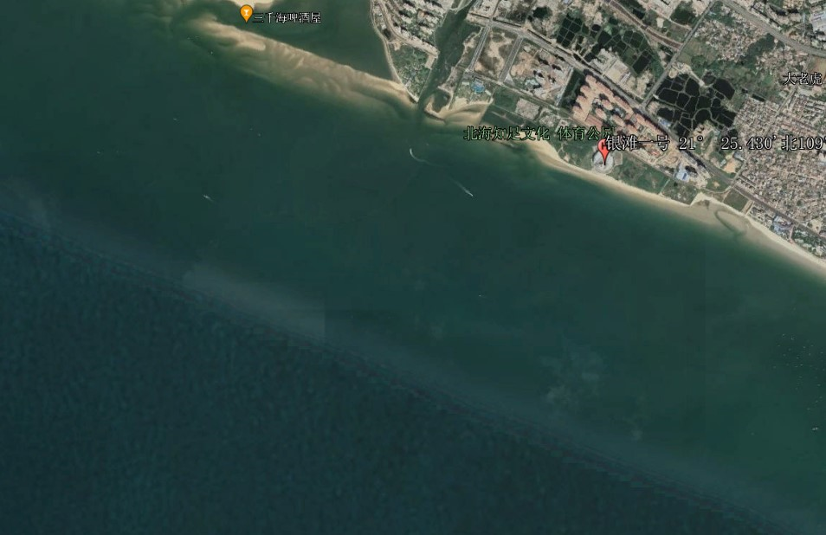

**Appendix 2 Course race Diagram**

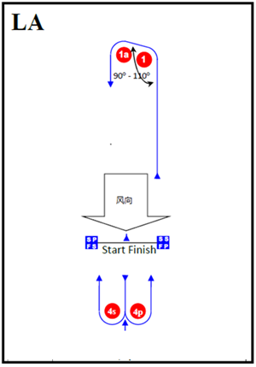

LA1 start-1-1a-4S/4P -finish

LA2 start-1-1a-4S/4P-1-4S/4P -finish

LA3 start--1-1a-4S/4P-1-4S/4P-1-4S/4P-finish

**Appendix 3: “TEAM” Space on each side of the hull**

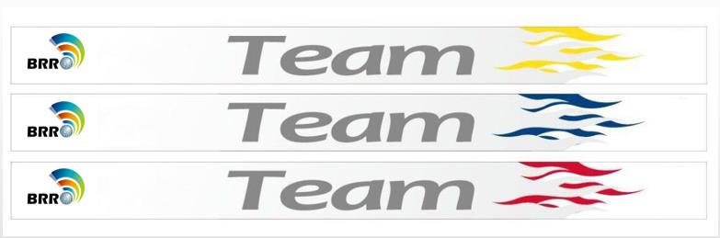

**Appendix 4: More information about fee payment and equipment rental**

1. For teams that need to issue invoices to their company accounts, please provide detailed invoicing information, which must be completely consistent with the remittance account. For teams that need to issue invoices to their company accounts after swiping their cards, the bank card information must be consistent with the company account information.
2. All registration fees and rental fees for boats and equipment from the OA shall be remitted to the following account:

|  |  |
| --- | --- |
| **Account name** | Guangxi Yachting Association |
| **Account number：** | **178812010113586498** |
| **Bank Address：** | **Nanning Urban Rural Credit Cooperative Union Taoyuan Branch** |

Contact: Mr Jian LI

TEL: +86 13377222222